Name : K.AravindRoyal

Trainer Name:- Harshee pithoda

Course Name:-python for machine learning

Date:-07/06/2022

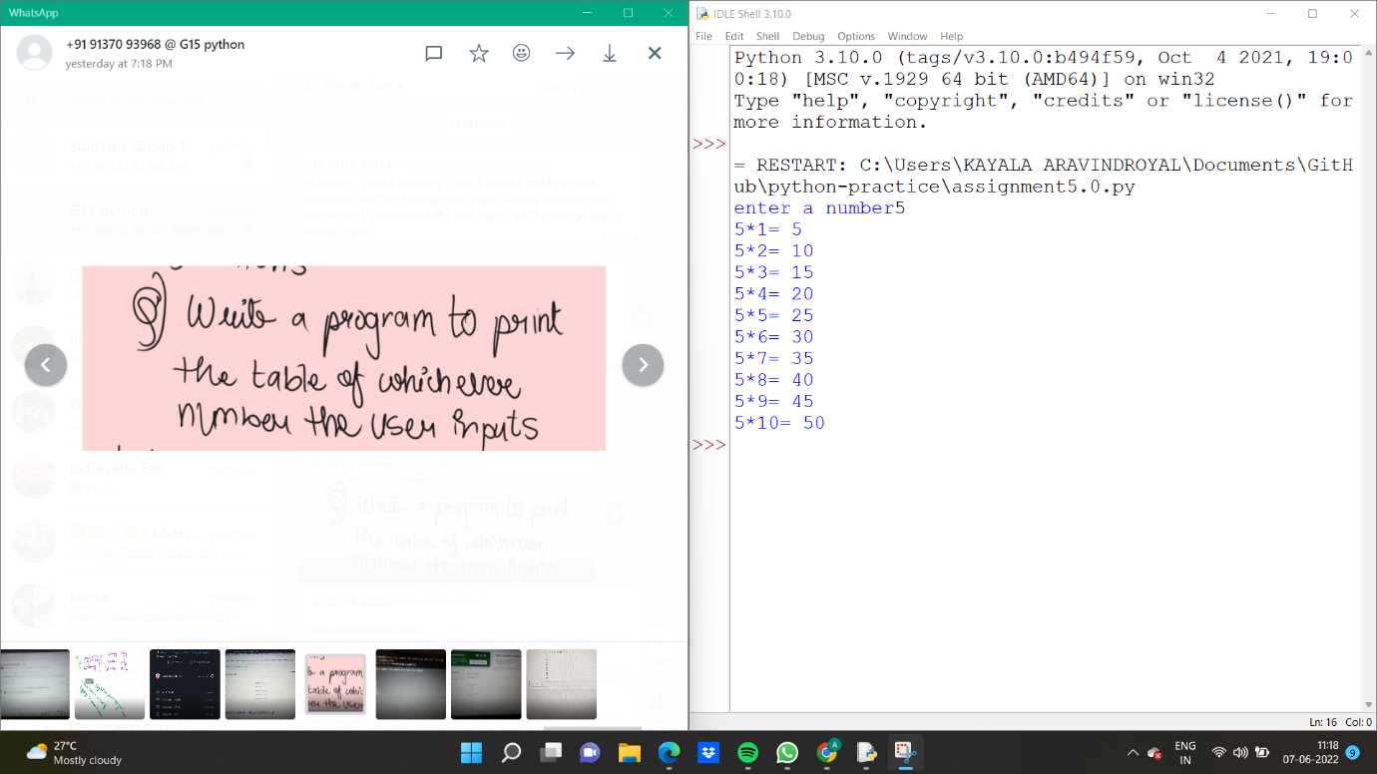

a=int(input('enter a number'))

for i in range(1,11):

print('{}*{}='.format(a,i),a*i)

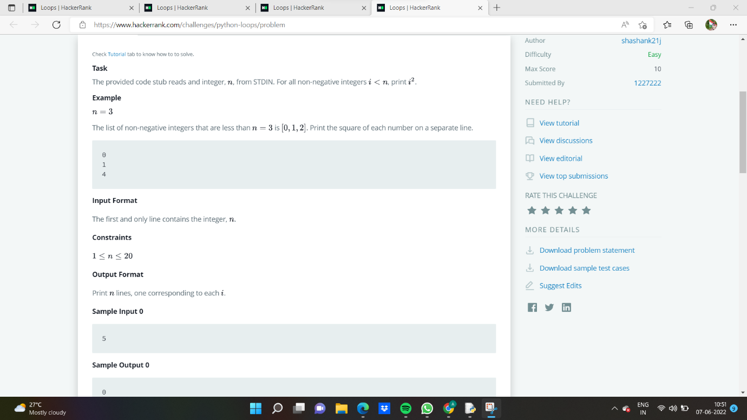

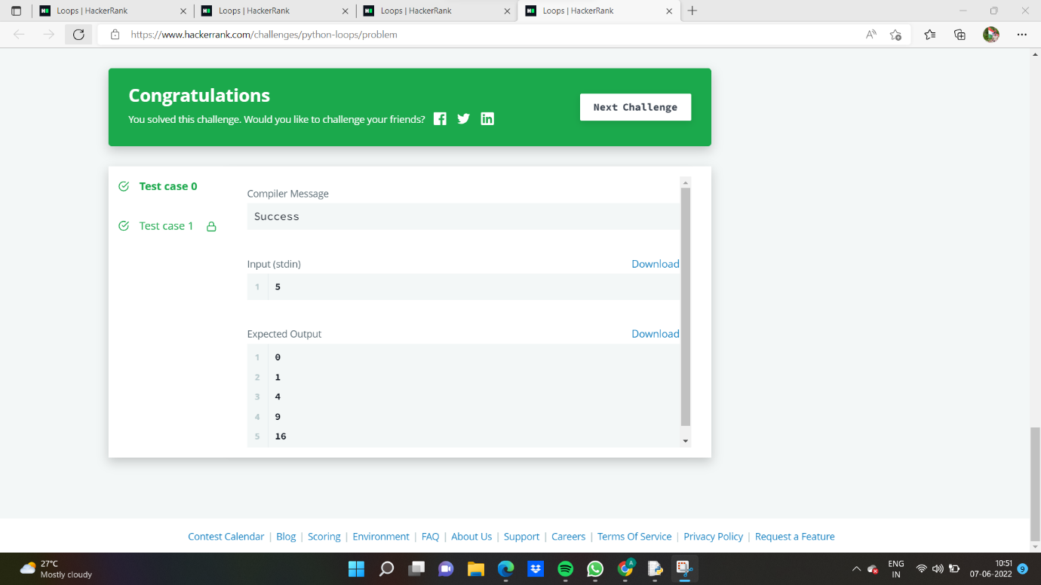

a=int(input('enter a number'))

for i in range(0,a):

print((i+1)**2)

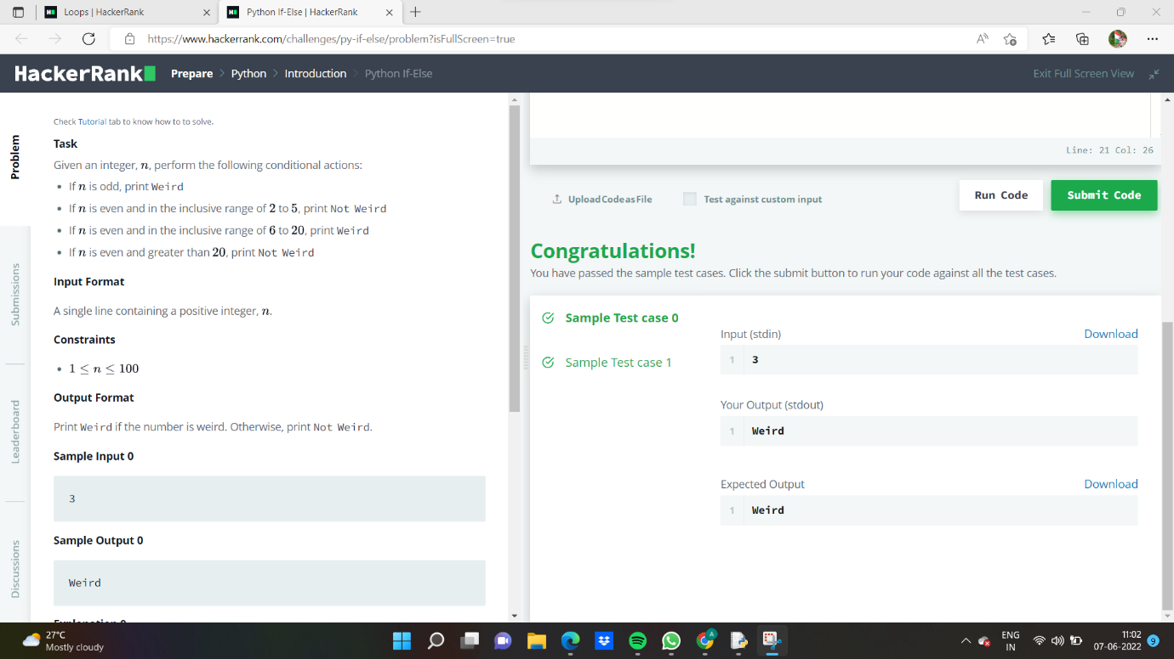

if __name__ == '__main__':

n = int(input().strip())

if n%2==1:

print('Weird')

if n%2==0:

if 2<=n<=5:

print('Not Neird')

if 6<=n<=20:

print('Weird')

if n>20:

print('Not Weird')

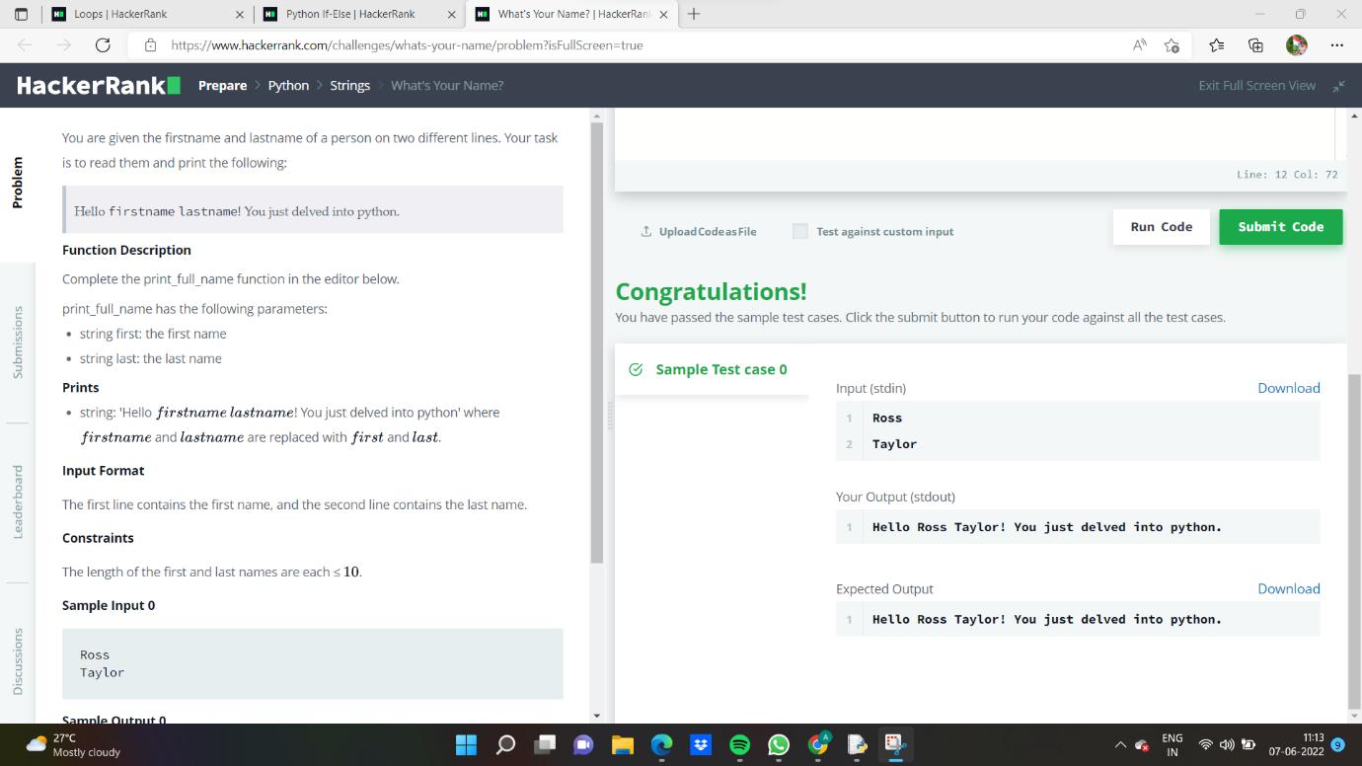

def print_full_name(first, last):

# Write your code here

print('Hello {} {}! You just delved into python.'.format(first,last))

if __name__ == '__main__':

first_name = input()

last_name = input()

print_full_name(first_name, last_name)